PART 4: The Challenge
Background: Smart Parking Barrier System.
A local university wants to implement a smart parking barrier system at its main gate. The
system should:
- Automatically open the barrier for registered staff and students.
- Count the number of cars in the parking lot.
- Display the number of available spots.
- Trigger an alert if someone tries to enter when the parking is full.
The goal is to simulate and implement the logic using the Integrated Problem-Solving Process.
Step 1: Understand and Define the Problem (Analyse)
The problem is basically about creating a system that can manage the university’s parking automatically. The barrier should open on its own when a registered staff or student arrives, and the system needs to keep track of how many cars are inside at any moment. It also has to show how many parking spots are still free so drivers know if they can enter. If the parking lot is full, the system should stop the barrier from opening and trigger an alert so no one can enter.

Step 2: Organise and Describe the Data
- Features : automatic access, vehicle count, alert for full capacity.
- Inputs: RFID/ID of user, sensor for car entry/exit, max capacity (e.g, 100).
- Outputs: barrier control(open/close), display of free spots, alert system.
- Assumptions: Each vehicle has a unique ID, seonsors are reliable, capacity is fixed.
- Expected outcome: Only registered users can enter, system keeps track of space.
- Sketch: Block diagram showing RFID reader > Logic > Barrier + Display + Alert.

Step 3: Plan the Solution (Design the Algorithm)

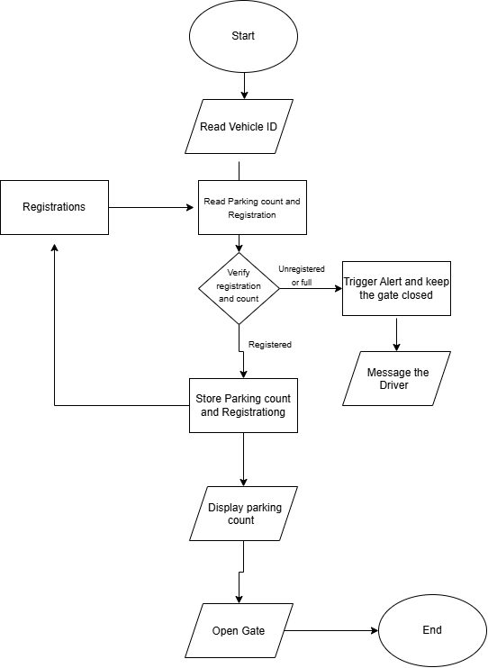

Step 4: Implement the Solution (Word Coding)
- Once upon a time..
- Read Vehicle ID (input)
- Check if the vehicle is registered.
- If not registered, slam the boom gate over the bumper of the car (that is, do not open the gate)
- If registered, but the car park is full(always happens at uni), do not open the gate and gently message the driver the number of spots.
- If registered and there are enough spots, open the gate, yay!!
- Note that all the transactions are being stored in a database called “Registrations”
Step 5: Test and Refine the Solution (Debug and Verify)
Assumptions:
- Max number of cars allowed: 100
- Registrations database is up to date ( actual car park spots availability)
Test for ..
- Registered User with 95 cars > Allow entry.
- Registered user with 101 cars > Alert + entry locked + message
- Unregistered user > Alert + Entry locked + message
Suggested improvements
- Add logging feature for entries
- Integrate a web dashboard for monitoring
- Add override for emergency vehicles

